**ALLEN HUMAN REFERENCE ATLAS - 3D, 2020**

**Version 1.0.0**

The Allen Human Reference Atlas - 3D is a parcellation of the adult human brain in 3D, labeling every voxel with a brain structure spanning 141 structures. These parcellations were drawn by Song-Lin Ding, and adapted from his prior 2D version of an adult human brain atlas.

These parcellations were drawn on the MRI reference brain volume “ICBM 2009b Nonlinear Symmetric”, a non-linear average of the MNI152 database of 152 normal brain images. The iterative procedure results in an average that combines both high-spatial resolution and signal-to-noise and not subjected to any particularity of any single brain. To obtain the reference volume, please refer to the McConnell Brain Imaging Center website for download and terms of use available from [http://www.bic.mni.mcgill.ca/ServicesAtlases/ICBM152NLin2009; 293](http://www.bic.mni.mcgill.ca/ServicesAtlases/ICBM152NLin2009;) Copyright © 1993–2004 Louis Collins, McConnell Brain Imaging Centre, Montreal Neurological Institute, McGill University.

[[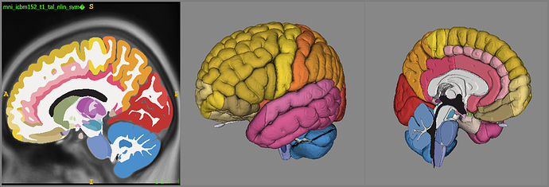](https://global.discourse-cdn.com/standard10/uploads/brainobservatory/original/1X/7d4263052ef20e1877e46cf869773a8184cf5512.jpeg)](https://global.discourse-cdn.com/standard10/uploads/brainobservatory/original/1X/7d4263052ef20e1877e46cf869773a8184cf5512.jpeg" \o "image)

[image1405×479 469 KB](https://global.discourse-cdn.com/standard10/uploads/brainobservatory/original/1X/7d4263052ef20e1877e46cf869773a8184cf5512.jpeg" \o "image)

A 2D sagittal cross-section overlaid on MNI space and 3D medial and lateral rendering of the new human parcellation volume visualized using ITK-SNAP application.

**USAGE**

Example python scripts have been included to demonstrate:

* how to download structure information and ontology from the Allen Brain API
* use of the annotation volume in context of a hierarchical ontology
* creation of ITK-SNAP compatible files to visualize the parcellation in 2D and 3D

**TERMS OF USE**

These materials are now provided under the Attribution International 4.0 (CC BY 4.0) license as of Sept. 1, 2022, which is available at <https://creativecommons.org/licenses/by/4.0/>.

**CITATION**

Citation of these materials should conform to the Allen Institute Citation Policy: [https://alleninstitute.org/legal/citation-policy/ 14](https://alleninstitute.org/legal/citation-policy/)

**Allen Human Reference Atlas - 3D, 2020 Citation information:**

| **Resource Name:** | **Allen Human Reference Atlas – 3D, 2020** |
| --- | --- |
| **Version:** | 1.0.0 |
| **Research Resource Identifier (RRID):** | RRID:SCR_017764 |
| **Copyright notice:** | © 2019 Allen Institute for Brain Science |
| **Dataset citation:** | Song‐Lin Ding, Joshua J. Royall, Susan M. Sunkin, Benjamin A.C. Facer, Phil Lesnar, Amy Bernard, Lydia Ng, Ed S. Lein (2020). “Allen Human Reference Atlas – 3D, 2020," RRID:SCR_017764, version 1.0.0. |
| **Available from:** | [http://download.alleninstitute.org/informatics-archive/allen_human_reference_atlas_3d_2020/version_1/ 351](http://download.alleninstitute.org/informatics-archive/allen_human_reference_atlas_3d_2020/version_1/) |

The anatomic structure ontology adapted for use in the 3D atlas was based on the 2016 version of the 2D atlas, published in final form here.

|  |  |
| --- | --- |
| Publication Citation for structure ontology: | Ding, S.L., Royall, J.J., […], Lein, E.S. Comprehensive cellular‐resolution atlas of the adult human brain. Journal of Comparative Neurology, Volume 524:16, pages 3127–3481, 1 November 2016, DOI 10.1002/cne.24080. |

**SUPPORT**

These materials are provided as-is, without direct support. Community discussion around this resource is available here at [https://community.brain-map.org/ 31](https://community.brain-map.org/).

**ACKNOWLEDGEMENTS**

Creation of the 3D parcellation volume was supported by the Allen Institute for Brain Science, and by the National Institute of Mental Health under Award Number 1U01MH114812-01 (PI: Ed Lein, Allen Institute for Brain Science).

The 2D atlas and anatomic structural ontology upon which it was based was supported by the Allen Institute for Brain Science, and by the National Institute of Mental Health under Award Number RC2MH089921 (PIs: Ed Lein & Michael Hawrylycz, Allen Institute for Brain Science).